# Teamfight Tactics Stats

## What is TFT?

Teamfight Tactics is a free-for-all auto-battler video game. Your goal is to grow your team of champions and be the last player standing. For more information, see <https://teamfighttactics.leagueoflegends.com/en-us/news/game-updates/what-is-teamfight-tactics/>.

The gameplay is split into stages, each having seven rounds. Stage 1 is special in that there are only four rounds.

## What is TFT Stats?

TFTStats is a statistics tracker that help players improve by using players' game results to display meaningful statistics for all areas of the game.

## Entering data

TFTStats requires players to input the game state as it progresses. Since this is difficult to do in the middle of the game, the player only needs to screenshot their game at the start of a few rounds. In particular:

* **Stage 1**: screenshot at the start of **round 2.**
* **Stages 2-4:** screenshot at start of **round 1, 2, and 5**. The screenshot at round 1 will help you fill out the last bit of information from the previous stage.
* **Stage 5+:** screenshot at start of **round 1 and 5**.
* When you die, it is unlikely you will have time to screenshot your final game state. Instead, go to <https://lolchess.gg/leaderboards>, select your region and input your username. Find your game and use it input your final game state into the app.

Here's a demo on how to input game results:

1. On the Home page, click the + button.
2. Your game has started. You have just picked an item from the carousel. Take a screenshot.   
   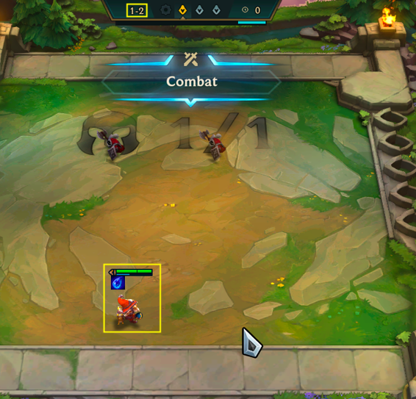
3. Stage 2 round 1 (2-1) has started. Take a screenshot. Here's what stage 1 should look like:  
   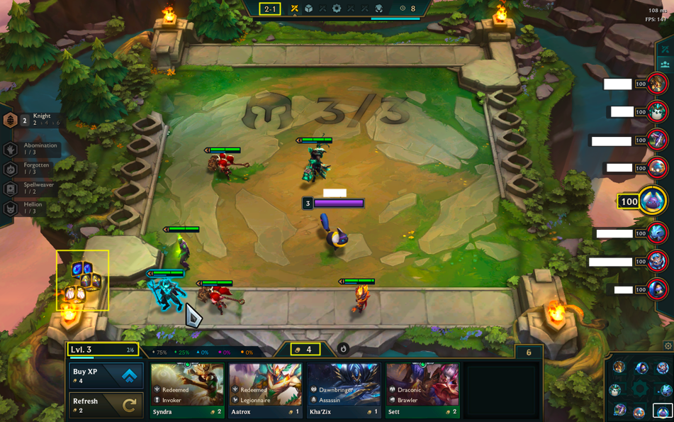 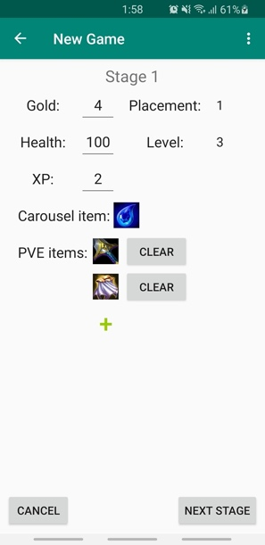
4. 2-2 has started. After you select an armory item, take a screenshot.  
   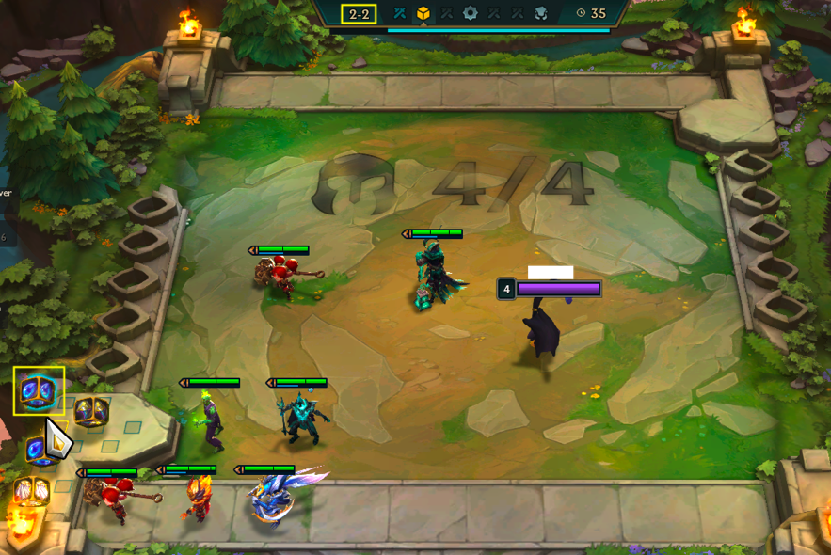
5. 2-5 has started. Since you selected a carousel item in the previous round, take a screenshot.  
   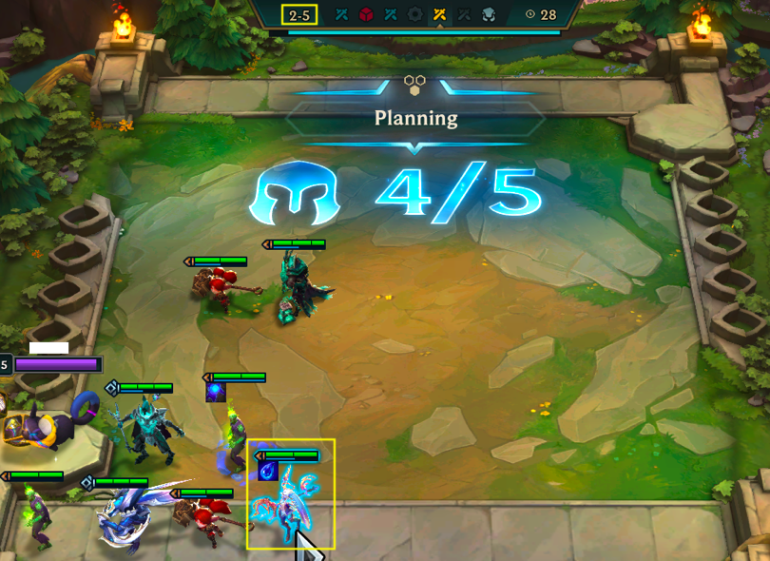
6. 3-1 has started. Take a screenshot. Here's what stage 2 should look like:  
   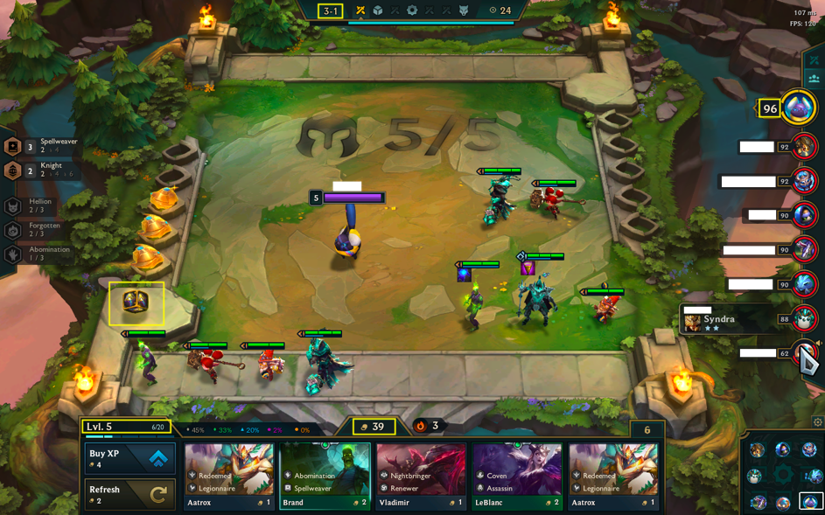 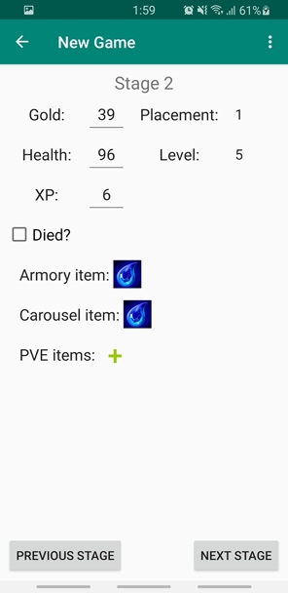
7. This continues until 5-1. From 5-2 and onward, there is no armory item so you do not need to screenshot round 2.
8. 5-5 has started. Take a screenshot. Here I accidentally took the screenshot one round late but I remembered what I picked.  
   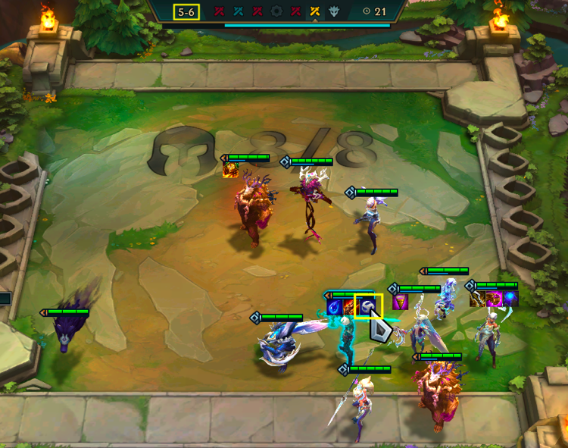
9. 6-1 has started. Take a screenshot. Here's what stage 5 should look like:  
   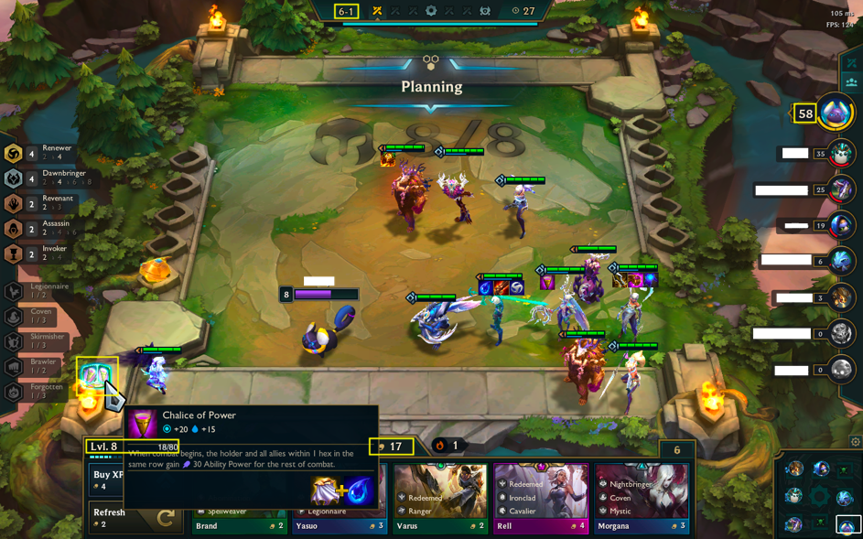 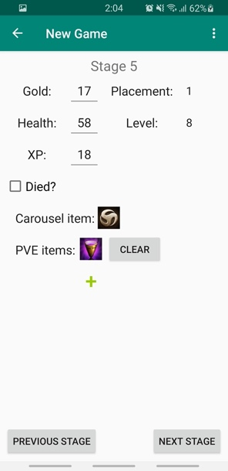
10. Once the game has ended and you have been eliminated, go to <https://lolchess.gg/leaderboards>, input your username and find your game. Depending on when you died, you may or may not have to fill out certain fields. For example, if you died before round 4, you will not have to add carousel or pve items. You may also not know your xp, so don't worry about it. Here's what your final stage and team comp should look like:  
    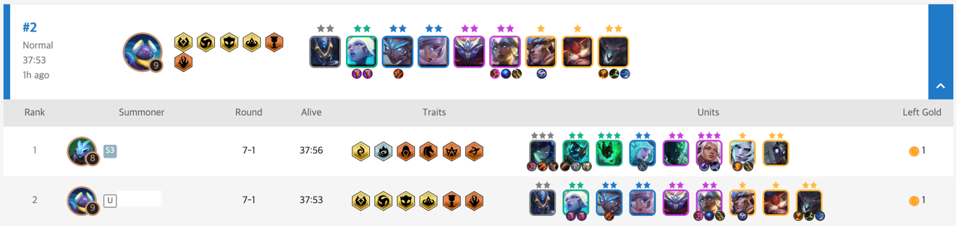

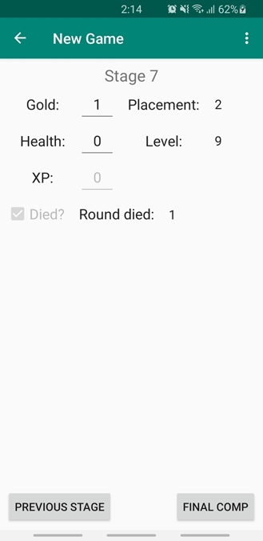 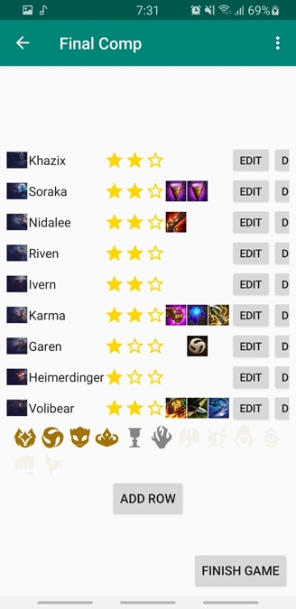

## Viewing statistics

When you click the top left hamburger, you will see some statistics pages.

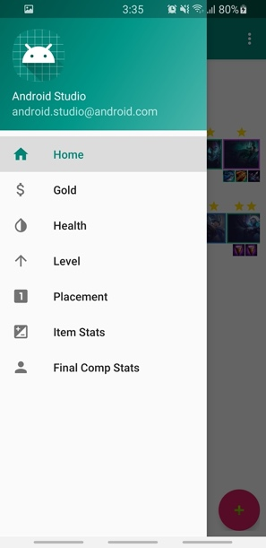

### Home

You will see a list of your last 10 games. Each game will show your final placement, final team comp, team traits, and each champion's items. To view more information about a game, you can tap anywhere on the game's row. Then you will see the items you got from armory, carousel, and pve. You can also see the progression of gold, health, level, and placements.

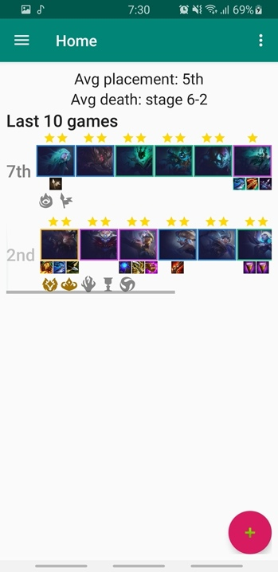 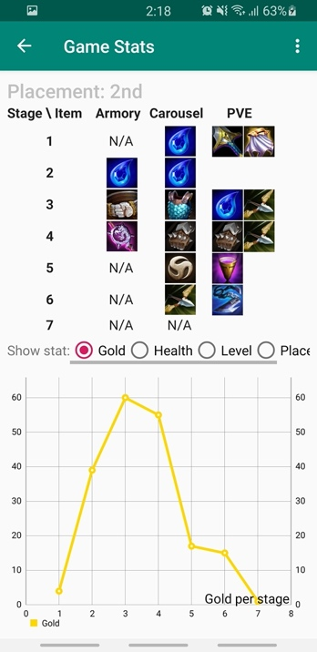

### Chart, line chart Description automatically generatedGold, Health, Level, and Placement

These pages will show you the average gold/health/level/placement per stage, separated by the end game placement. For example, suppose you had three games, all that only lasted two stages:

Game 1: stage 1 had 1 gold, stage 2 had 5 gold, and you placed 2nd.

Game 2: stage 1 had 5 gold, stage 2 had 3 gold, and you placed 2nd.

Game 3: stage 1 had 1 gold, stage 2 had 1 gold, and you played 8th.

Then the red line will show 3 gold at stage 1 and 4 gold at stage 2. The purple line will show 0 gold at stage 1 and 0 gold at stage 2. The average line shows overall average (aka merging all the placements). In this case, it will show 2.33 gold at stage 1 and 3 gold at stage 2.

You can use the checkboxes to hide certain lines. If a line doesn't appear even when the box is checked, then you have no games where you ended at that placement. The bottom of the graph shows all possible lines.

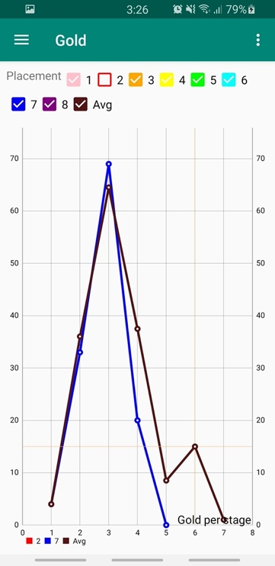

### Item Stats

This page will help you learn which items get you the best results.

Under "Average Placement by Item", you can enter an item name and view your average final placement when you got that item at a specific stage. For example, in the following screenshot, my average final placement is 2nd when I got a Tear of the Goddess from stage 2.

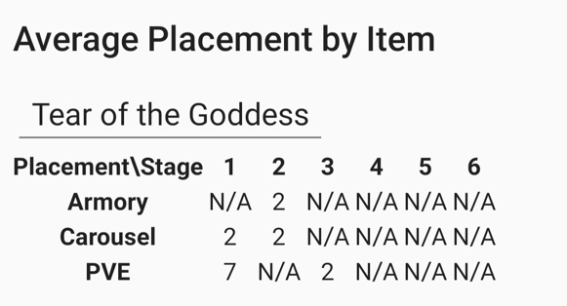

Under "Best Items", you can view the items that give the highest average final placement. For example, in the following screenshot, when I get a Tear of the Goddess from stage 2 armory I have the highest average placement compared to all other items.

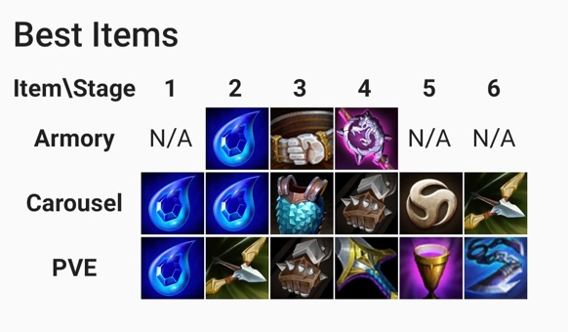

#### Final Comp Stats

This page will help you learn which champions perform the best and which team compositions you are successful with.

Under "Average Placement by Trait", you can enter a trait and view your average final placement when your team composition has that trait. It is also divided by trait levels.

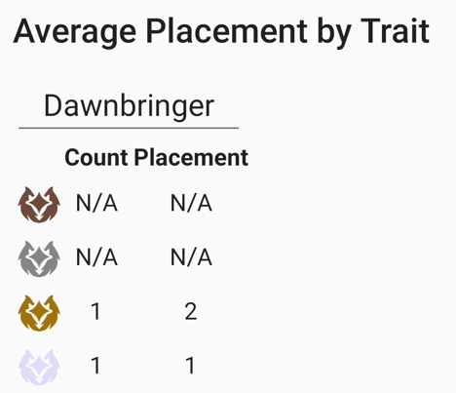

Under "Best Final Traits", you can view three traits that give the highest average final placement. These are sorted by best placement, count, and the trait level. You can press and hold the trait image to view the trait name and level.

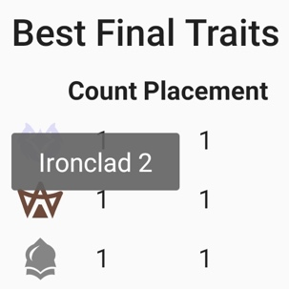

Under "Average Placement by Champion", you can enter a champion and view your average final placement when the champion is in your final team. The items that are most successful on the champion are shown.

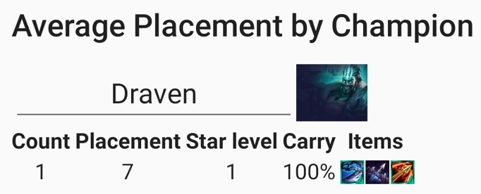

Under "Best Final Champions", you can view three champions that give the highest average final placement. These are sorted by placement, count, star level, carry percentage, and number of items.

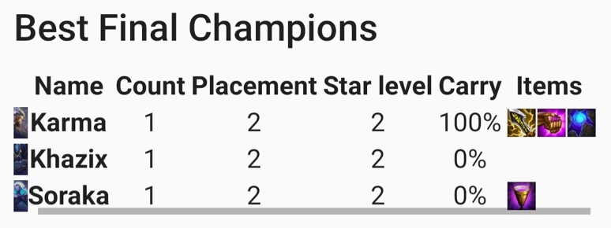

Under "Average Team Cost Per Placement", you can view a line chart of your final team cost, separated by your final game placement. For example, in the following screenshot my average team cost when I place 2nd is above 71.

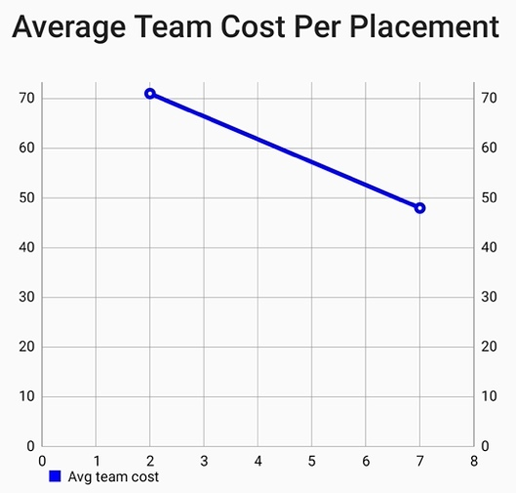

## Coming up

### Features

#### Edit and Delete games

As a user, I want to edit an existing game. This includes changing a stage's values, adding new stages, and modifying my team.

Acceptance criteria:

* There are three buttons: Delete, Edit stages, and Edit team
* When Delete is clicked, a warning popups up for confirmation with text "Are you sure you want to delete the game? All data related to the game will be removed and will not appear in statistic pages.". The popup has two options "Cancel" and "Yes".
* When Edit stages is clicked, the first stage is loaded (StageFragment). The user can modify the stage. There are buttons to Save, Next Stage, Previous Stage (if applicable), and Exit.
* Exit should go back to the original page where Edit stages was clicked
* When Edit team is clicked, the team comp is loaded (FinalCompFragment). Same functionality as before. There is a button "Exit". When the user edits/deletes a champion, the team is immediately updated.

Design options:

* put Edit and Delete button on Home, next to the team
* put Edit and Delete button on Game Stats, at bottom of page
* For stage navigation, provide options like "Save and next", "Save and exit". If user makes changes and wants to go to the previous/next stage without saving, they should have that option.

#### Home page: support viewing more than 10 games

As a user, I want the option to view the next 10 games.

Acceptance criteria:

* next to the label "Last 10 games", there is a selector to go to the next 10 games or select a specific page of games
* when a page has been selected, the games should update
* replace the label with "Games 1-10" and update based on the current page

#### Add a statistics page for stage and round of elimination

As a user, I want to know my average placement when I die at stage _ round _ .

Acceptance criteria:

* create a line chart where x-axis is stage and round and y-axis placement
* y-axis scale is 1-8, with a label at each value
* x-axis scale depends on the most late stage/round.
* since each stage is only 7 rounds, each x value should be a decimal of stage + (round / 7).

### Existing Bugs

#### Using built-in back on a Stage page causes issues

When inputting stage data, there is a manual "Previous Stage" or "Cancel" button to replace Android back functionality. If Android back is used, the stage will be incorrect. However, Android back does work for all other pages.

Steps:

1. On Home, click +
2. Use Android back
3. Click +   
   Expected: every field is blank   
   Actual: gold, health, and xp are set to 0, indicating that the game was not reset.